Configuration of Robot

Introduction to robot configurations
A robot’s configuration is defined by the set of parameters (usually joint variables) that uniquely describe the robot’s position and orientation at any given time. It simply refers to specific physical arrangement and geometric structure of a robot, especially how its parts are connected and how they move relative to one another.
Parameters are often called Degrees of Freedom (DOF)- the number of independent motions the robot can make
Configuration describes the entire internal state of the robot (all joint values). Position (or pose) describes only the end effector location and orientation in space.
A configuration depends on 1) type of joints (rotational or linear), 2) Number of joints, 3) arrangement of joints and links, 4) constraints (mechanical or task based).
Configuration is important for Kinematic analysis, Workspace analysis, Motion planning, Control Systems, Robot classification.

Robot configurations
- Serial Robots-
A sequence of links connected by joints, starting from a fixed base and ending at an end effector
Types: Articulated manipulators, SCARA robots, Cartesian Linear Arms
Kinematics: Forward Kinematics – simple chain product of transforms, Inverse – Multiple solutions with singularities.
Applications: Industrial assembly, Material handling.
Pros: Large workspace, Easy to program; Cons: Lower stiffness, Accumulated error

- Cartesian Robots –
Axes move in straight lines, All joints are prismatic
Kinematics: simple and linear – transforms map directly to position.
Applications: CNC positioning table, 3D printers.
Pros: simple control, high precision; Cons: Limited dexterity.
- SCARA (selective Compliance Assembly Robot Arm)
A 4 DOF arm with two parallel rotary joints and a vertical prismatic motion
Applications: Hight speed assembly, packaging.
Feature: Laterally compliant in X–Y plane, rigid in Z direction → excellent for inserting parts.
- Parallel robot –
Multiple Kinematic chains connect the base to the end effector.
Example: Stewart Platform – Six adjustable legs connect base to the moving platform.
Applications: Flight simulators, precision machining, vibration compensation systems, Motion platforms
Pros: High stiffness, High payload, Precise motion
Cons: Difficult control and workspace limitations
Research focus: Dynamic load balancing, High accuracy tasks like micro machining, redundancy and singularity avoidance.

Research today:
Redundant robots: more Dofs than necessary; Advantage: avoid singularities, optimize trajectory.
Reconfigurable robots: Change structure dynamically, Swarm like or modular systems
Area | Core Focus
Modular Robotics | Self-reconfiguration; plug-and-play link modules
Soft Robotics | Compliance, safe interaction with humans
Aerial Manipulation | Drones with manipulators for complex tasks
Underwater Robotics | Buoyancy control + multi-DOF manipulators
Hyper-redundant Robots | Snake-like robots for constrained spaces

Parallel robots
A parallel manipulator is a mechanical system that uses several computer controlled serial chains to support a single platform, or the end effector. Best parallel manipulator is formed with 6 linear actuator that support a movable base for devices such as flight simulators. This device is called the Stewart platform or the Gough- Stewart platform, the actuators are paired on both the basis and the platform. The systems are articulated robots (type of robot with rotary joints) that use the similar mechanism for the movement of either the robot on its base or more manipulator arms.

Chapter 1 - History
Pollards parallel robot -
Pollards parallel robot is known as the first industrial parallel robot design. The invention represents a five-DOG-three-branched robot. Three proximal arms are pivoted by rotary motors fixed to the base, and three distal arms are connected to the third via ball joints, while a tool head is connected to the third distal arm via a universal joint.
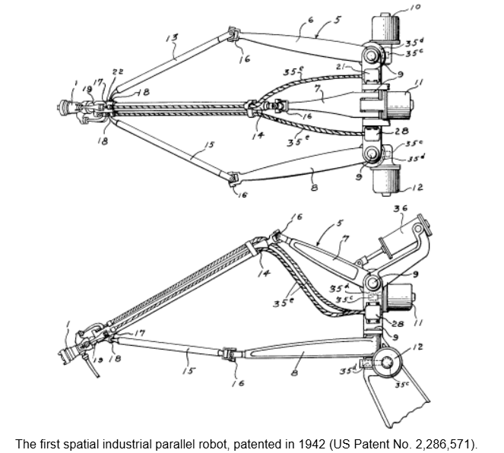
On October 29, 1934, Willard pollard jr. filed a patent for a spray-painting machine.
The patent contains of two parts – 1) an electrical control system, 2) a mechanical manipulator.
The control system consists of perforated films, the hole density of which is directly proportional to the speed of the motor. The mechanical component, is a parallel robot based on a pantograph actuated by two rotary motors at the base.
Gough's Tire-Testing Machine Is Still In Shape
A couple of years later, in 1947, on the other side of the Atlantic, a new parallel robot was invented,—the one that became the most popular, the one that changed an industry, and the one that has been replicated over a thousand times—the variable-length-strut octahedral hexapod.
Gough or Stewart platform? Or ... Cappel platform?
In 1965, Stewart's famous paper appeared in the proceedings of the (British) IMechE. In that paper, Mr. Stewart describes a 6-DOF motion platform for use as a flight simulator. The proposed parallel mechanism, however, is different from the octahedral hexapod that is, paradoxically, often referred to as the "Stewart platform." In the same proceedings, Stewart's paper is followed by ardent discussions from scientists and engineers, one of which was Dr. Gough who reminded of the existence of his tire-testing machine.
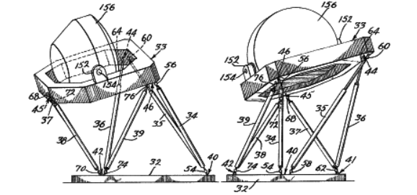

Chapter 2 – Definition
Mechanism where the end effector is connected to the base by two or more independent kinematic chains. The chains operate in parallel, sharing a bed.
A parallel manipulator is designed so that each chain is usually short, simple and thus be rigid against unwanted movement. Error in one chain positioning are averaged in conjunction with the others, rather than being cumulative.
Each actuator must still move within its own degree of freedom, as for a serial robot. However, in a parallel robot the off-axis flexibility of a joint is also constrained by the effect of the other chains. It is the closed loop stiffness that makes the overall parallel manipulator stiff relative to its components.
Steward platform- Hexapod chains use prismatic joint linear actuators between any axis universal ball joints. The ball joints are passive that is it is simply free to move.
Delta robots – have mounted rotary actuators that move a light, stiff, parallelogram arm. The effector Is mounted between the tips of three of these arms and again, it may be mounted with simple ball joints.
Advantages of a parallel manipulator includes is that the heavy actuators may often be centrally mounted on a single base platform, the movement of the arm taking place through struts and joints alone. The reduction in mass along the arm permits a lighter arm construction. thus, lighter actuators and faster movements. This centralisation of mass also reduces the robot's overall moment of inertia, which may be an advantage for a mobile or walking robot.
Aspect | Serial Manipulators | Parallel Manipulators
Basic Structure | Consist of a chain of rotary joints connected in series, each allowing motion in one axis under actuator control | Consist of multiple legs connecting the base to the end-effector, working simultaneously
Rigidity | Rigidity depends heavily on the quality of each joint; unwanted flexibility in one joint affects the whole arm | High rigidity can be achieved even with low manipulator mass
Error Accumulation | Hysteresis and off-axis flexibility accumulate along the kinematic chain and may be amplified at the end-effector | Errors do not accumulate in the same way because multiple legs constrain motion
Precision | Precision is a compromise between complexity, mass, cost, and joint quality | Very high precision is achievable
Speed | Generally slower due to higher moving mass and accumulated flexibility | Capable of very high-speed movements
Mass vs Load Capacity | Manipulator mass is often large relative to the payload | Small manipulator mass relative to the load being manipulated
Workspace | Relatively large workspace | Limited workspace due to geometry, leg length limits, and collision constraints
Singularities | Less critical and easier to manage | Presence of singular positions where control becomes unstable and internal forces may become infinite
Control Behaviour | More linear and predictable control | Highly nonlinear; required commands depend strongly on position in the workspace
Safety at Singularities | Not typically catastrophic | Singularities may cause extreme internal forces, potentially damaging the manipulator
Typical Applications | General-purpose industrial robots, assembly arms | Flight simulators (high speed with large masses), particle accelerator lenses (extreme precision)
Main Drawbacks | Accumulated flexibility, reduced precision at long reaches | Limited workspace, difficult singularity analysis, nonlinear control

Chapter 3 – The classification
Classification by degrees of freedom –
Type | DOF | Motion | Characteristic | Examples | Use Cases | Design
Full DOF Parallel Robots | 6 | Control of both position and orientation | Complex structure, high rigidity, high precision, more difficult control | Stewart Platform | Flight simulators, precision machining, motion platforms | Mature technology; complex kinematics and control
Lower-DOF Parallel Robots | 2, 3, 4 | Partial control of position and/or orientation | Simpler structure, faster motion, cheaper, easier to control | 3-DOF translational robots (Delta Robot), 3-DOF planar parallel robots | Pick-and-place systems, high-speed assembly, research prototypes | Main focus of modern research, not full 6-DOF systems

Classification by Motion Type
Motion | End-Effector Motion | Key Characteristics | Typical Applications | Examples
Translational Parallel Robots | Pure linear motion in X–Y–Z, no rotation | High stiffness, very high speed, simple kinematics, excellent repeatability | Pick & place, packaging, high-speed sorting | Delta Robot, Cartesian parallel robots
Rotational Parallel Robots | Rotation only, position fixed | Precise angular control, compact design, high orientation accuracy | Camera orientation, optical systems, sensor alignment | Spherical parallel manipulators
Mixed Motion Parallel Robots | Translation + rotation | Most general and versatile case, complex kinematics and control | Simulation platforms, machining, medical robotics | Stewart Platform

Classification by Limb Structure
Limb Structure | Joint Sequence Meaning | Typical Motion Effect | Design Characteristics | Example
UPS | Universal → Prismatic → Spherical | Full spatial motion (translation + rotation) | High rigidity, complex but precise | Stewart Platform (6-UPS)
RPR | Revolute → Prismatic → Revolute | Planar or spatial motion depending on arrangement | Simple, good controllability | Planar parallel robots
PRR | Prismatic → Revolute → Revolute | Often planar motion | Fast, lightweight designs | High-speed manipulators
RRR | Revolute → Revolute → Revolute | Pure rotational or planar motion | Compact but limited workspace | Spherical parallel robots

Chapter 4 – The Anatomy
Delta build: Delta Robot Build: Parallel Arm Mechanism with Servos - Zbotic
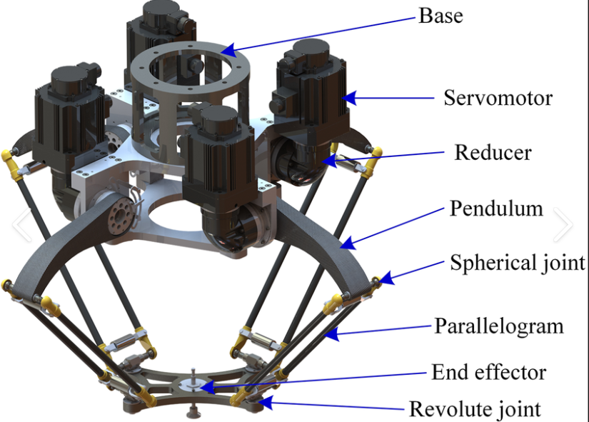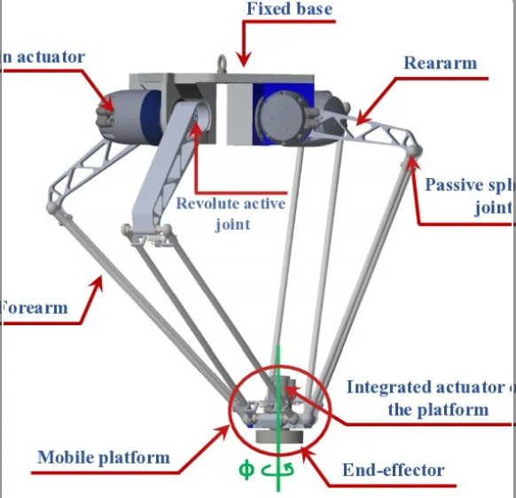
Mechanical - The robot built around two rigid bodies connected by multiple limbs.
- Fixed base is the foundation of the robot, it anchors the robot to the ground or the machine frame, provides reference for all the motion and supports actuators and absorbs all the reaction forces. It is very stiff and heavy compared to the moving parts, often triangular, circular, or hexagonal.
Material used: Cast aluminum (common in industrial robots), Structural steel (heavy-load applications), Carbon-fiber-reinforced frames (high-end, lightweight designs)
- Moving platform – Task happens here, the platform carries tools, grippers, sensors, cameras, or payload. Moves relative to the base via links. It is as light as possible to improve speed and accuracy and is very stiff to avoid deformation under load.
Materials used - Aluminum alloys (most common), Carbon fiber (high-speed or aerospace systems), Titanium (precision or medical robots)
- Kinematic chains – The limbs connect the base to the moving platform, each limb is a serial chain of joint, constraints motion together with other limbs. Mechanical components in each limb is links (rigid bar or tubes), joints (R,P,U,S), bearings, and rod ends or flexure joints.
Materials Used - Aluminum or steel links, Hardened steel joint pins, Precision bearings (angular contact, cross-roller).
Joints and Actuation –
- Actuated Joints – most common actuators are prismatic, and revolute joints. One actuator per limb reduces complexity, improves reliability, easier control and synchronisation.
- Actuator types – Electric actuators, hydraulic actuators, and pneumatic actuators.
Electric system -
- Power system - AC or DC power supply, Drives (servo drives or motor controllers), Emergency stop circuits, Overcurrent and thermal protection.
- Sensors – a) Joint level sensors - Encoders (optical or magnetic) Measure joint position, Linear scales (for prismatic joints), Limit switches, Home sensors
b) Platform-Level Sensors - Force/torque sensors, Vision systems
Variable | Why it Matters
Number of limbs | DOF & stiffness
Limb geometry | Workspace shape
Joint types | Controllability
Actuator placement | Dynamics & cost
Platform shape | Orientation coupling

Chapter 5 – The Kinematics
Constraint Screw Theory – In serial robots, motion is created by joints. In parallel robots, motion is mostly created by constraints. Parallel robots move not because joints allow motion, but because constraints remove unwanted motion.
A rigid body in space has 6 possible motions, 3 translations and 3 rotations. A constraint removes one or more of these motions. Screw theory represents each constraint as a screw( a 6D vector describing force/moment directions).
A screw is a 6D vector S=(f,m) (f= direction of force, m = moment caused by that force). There are two types, 1) motion screws(allowed motions), 2) Constraint screws(forbidden motions).
Constraint screws matter in parallel robotics because each limb applies force and moments to the moving platform , these forces block certain motions. The intersection of all limb constraints determines Robot DOF, motions type, and singularities.
Design rule: DOF = 6 – number of independent constraint screws

Delta robot
A delta robot is a type of parallel robot that consists of three arms connected to universal joints at the base. The key design feature is the use of parallelograms in the arms, which maintains the orientation of the end effector. Popular usage is picking and packaging in factories.
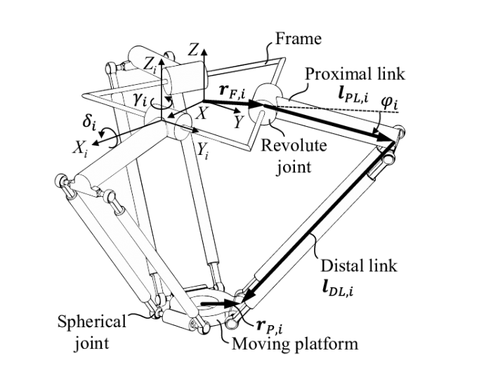
It consists of:
- Fixed Frame (Base)
- Proximal Link (Active Link)
- Distal Link (Passive Link)
- Spherical/ball joints
- Revolute Joints
- Moving Platform (end-effector)

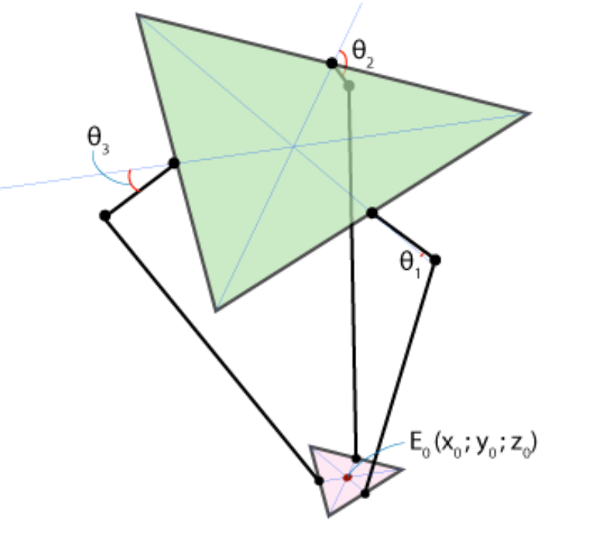
The platforms are two equilateral triangles: the fixed one with motors is green, and the moving one with the end effector is pink. Joint angles are theta1, theta2 and theta3, and point E0 is the end effector position with coordinates (x0, y0, z0). To solve inverse kinematics problem we have to create function with E0 coordinates (x0, y0, z0) as parameters which returns (theta1, theta2, theta3). Forward kinematics functions gets (theta1, theta2, theta3) and returns (x0, y0, z0).
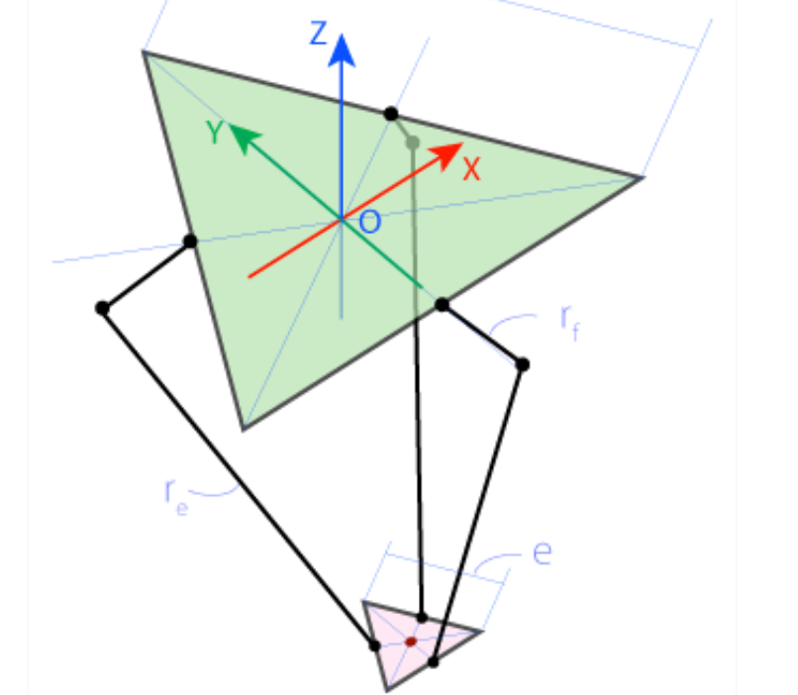
First, let's determine some key parameters of our robot's geometry. Let's designate the side of the fixed triangle as f, the side of the end effector triangle as e, the length of the upper joint as rf, and the length of the parallelogram joint as re. These are physical parameters which are determined by design of your robot. The reference frame will be choosen with the origin at the center of symmetry of the fixed triangle, as shown below, so z-coordinate of the end effector will always be negative.
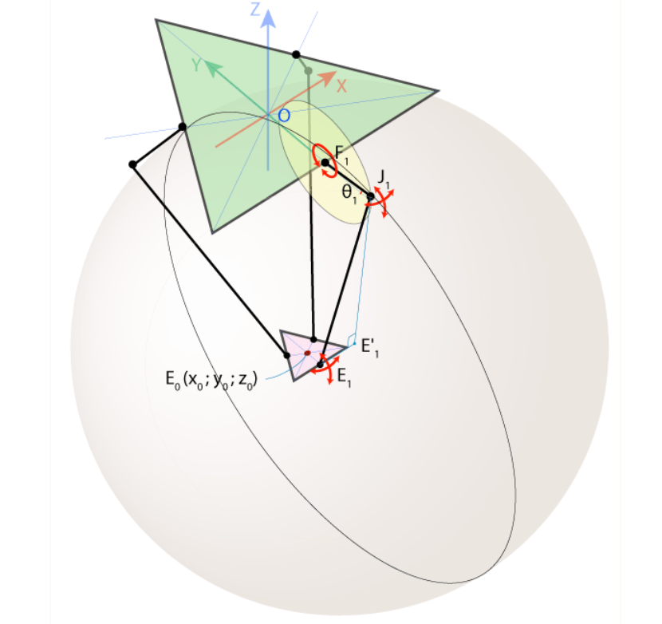
Because of robot's design joint F1J1 can only rotate in YZ plane, forming circle with center in point F1 and radius rf. As opposed to F1, J1 and E1 are so-called universal joints, which means that E1J1 can rotate freely relatively to E1, forming sphere with center in point E1 and radius re.
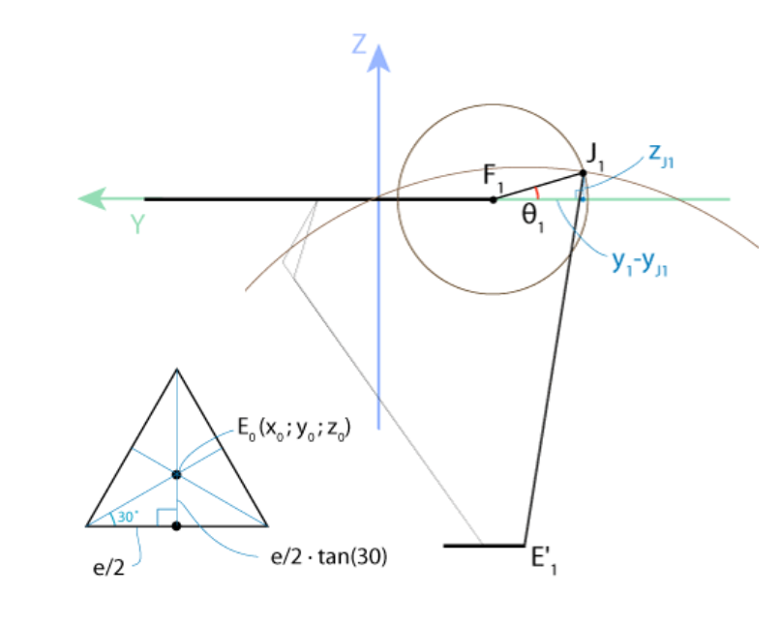
Intersection of this sphere and YZ plane is a circle with center in point E'1 and radius E'1J1, where E'1 is the projection of the point E1 on YZ plane. The point J1 can be found now as intersection of to circles of known radius with centers in E'1 and F1 (we should choose only one intersection point with smaller Y-coordinate). And if we know J1, we can calculate theta1 angle.
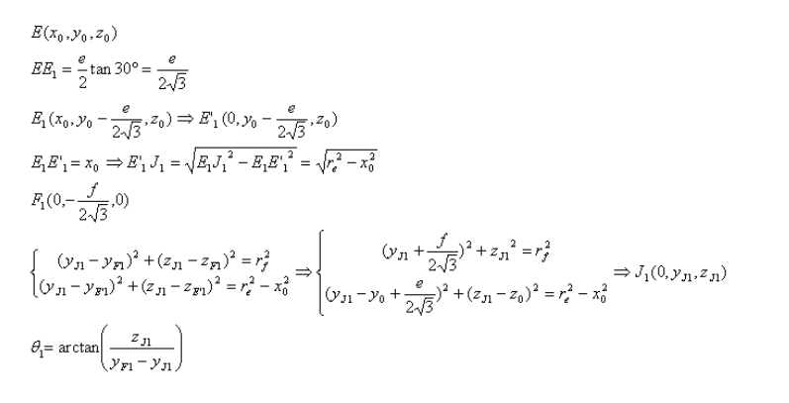
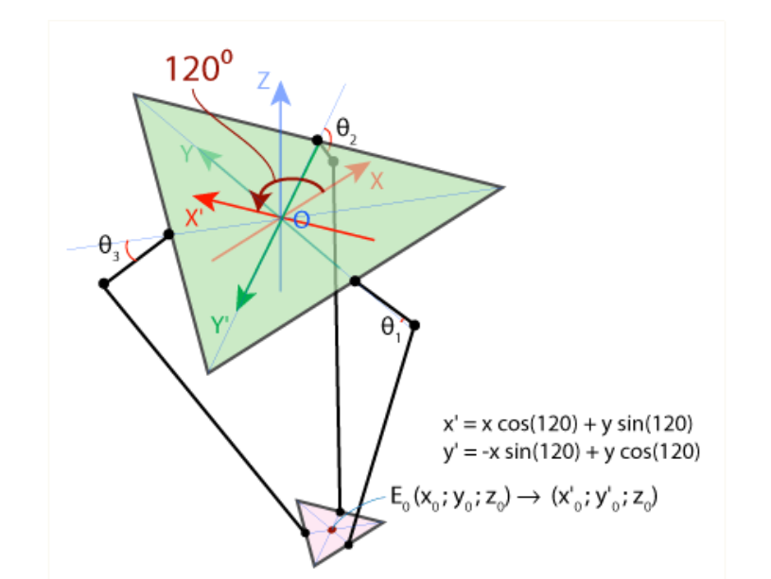
Such algebraic simplicity follows from good choice of reference frame: joint F1J1 moving in YZ plane only, so we cat completely omit X coordinate. To take this advantage for the remaining angles theta2 and theta3, we should use the symmetry of delta robot. First, let's rotate coordinate system in XY plane around Z-axis through angle of 120 degrees counterclockwise.
Forward kinematics functions gets (theta1, theta2, theta3) and returns (x0, y0, z0)
Work Space:
The workspace of a parallel robot is defined as the total volume swept out by its tool center point located on the mobile platform, as the robot executes all possible motions. The most common problem of parallel robots is the small workspace. One can use the workspace volume or surface as an objective function for optimization. In this sense, Researchers focused on workspace determination as a performance index, in order to design robots for specific industrial applications. The calculation of workspace of Parallel robots is a complex problem due to the difficulties of the kinematic modeling. However, the problem of workspace optimization of parallel manipulators, to obtain a prescribed workspace has been investigated in few articles. The concept of the prescribed workspace is a significant issue to optimize and also to synthesize a robot. The workspace of parallel manipulators is essentially influenced by the actuated joint variables, the range of motion of the joints and the mechanical interferences between the links of mechanism. In this work, we focused our interest in only some areas of the space which surrounds the robot, and limiting the robot workspace to the prescribed area. There are several papers studied this problem based on geometric techniques, and by using optimization algorithms to synthesize the geometrical parameters of parallel manipulators.
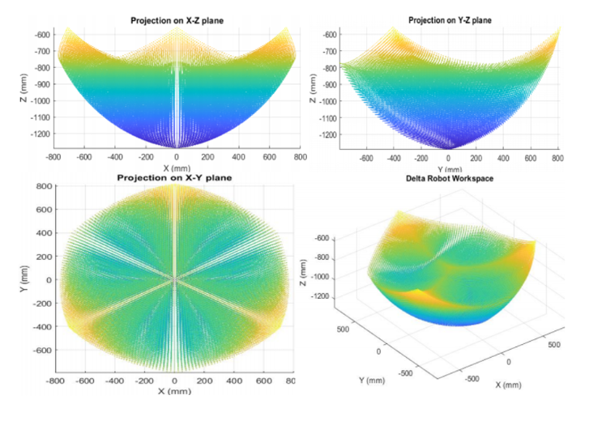
A typical delta robot has 3 DoF that can be increased by using additional end effector mechanism. Parallel robot can reach 5 DoF using certain mechanism that has separate motor for each link in the single arm but it's no more a delta robot.
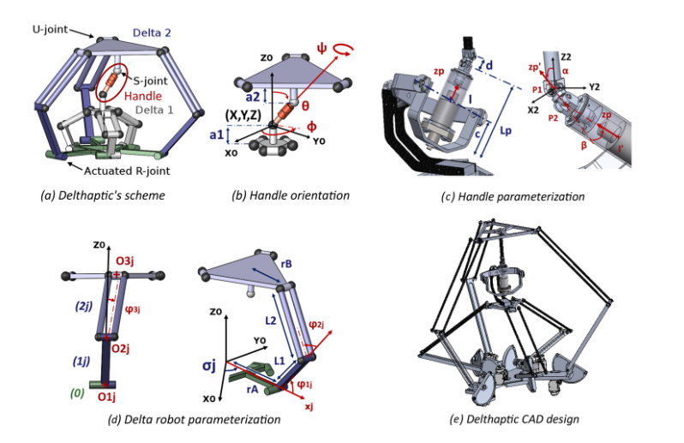
Workspace –
There are multiple workspaces,
- Geometric workspace – reachable positions ignoring forces
- Kinematic workspace – reachable without violating joint limits
- Singularity free workspace – reachable without singularities
- Dexterous workspace – reachable with full orientation capability
- Wrench-feasible workspace – forces/torques can be generated safely
Parallel robots are constraint- dominated system. Every limb adds constraints and constraints shrinks workspace. Higher the stiffness smaller the workspace.
The workspace of a parallel robot is dependent on
- Number of limbs (manipulator count) – more limbs = more constraints = smaller workspace. When workspace is critical minimal limb designs are preferred
- Limb geometry and arrangement – The key parameters are a) Limb length ratios, b) Base platform radius, c) limb inclination angles, d) symmetry
- Joint limits – workspace is directly bounded by actuator stroke limits, revolute joint angle limits.
- Singularities – Parallel robots suffer from internal singularities, a) type I is boundary singularities, b) type II is internal workspace holes.
How Workspace Optimization Is Done –
1) Define desired workspace volume
2) Impose singularity-free condition
3) Optimize:
- Limb lengths
- Base/platform geometry
4) Minimize:
- Condition number
- Actuator effort
Common Methods
- Geometric discretization
- Interval analysis
- Genetic algorithms
- Particle swarm optimization
- Multi-objective optimization
Objective functions include:
- Workspace volume
- Dexterity index
- Stiffness index
✔Workspace is defined by Jacobian rank
✔ Constraints, not geometry alone, dominate
✔ Increasing rigidity (more constraints) shrinks workspace
✔ Delta robot succeeds because it uses minimum necessary constraints

Chapter 6 – The study of other parallel robots
The study focuses on
- Parallel robots (Delta, Stewart, Cable-Driven)
- Workspace analysis / optimization
- Design structure & parameters
- Applications and research gaps
A. Reviews & Surveys
Paper 1: Parallel manipulator optimization has matured, but multi-objective, realistic performance models are needed for real industrial applications
While traditional frameworks heavily rely on idealized kinematic indices (like jacobian-based condition numbers) bringing parallel manipulators into intense industrial workflows requires complex, multi objective frameworks that incorporates real world physics (Russo, 2022; Mirshekari et al., 2016).
Methodology –
Multi-Objective Function formulation – instead of optimizing for a single metric like workspace volume, the mathematical models are constructed to simultaneously target conflicting objectives. These include the Global Conditioning Index (GCI = The Global Conditioning Index is a performance measure for robotic manipulators that evaluates the overall dexterity and error amplification across the entire workspace based on the condition number of the Jacobian matrix) for dexterity, actuator force minimization, structural stiffness, and dynamic trajectory smoothness (Russo, 2022; Mirshekari et al., 2016).
Kinematic and Dynamic Modelling – Inverse Kinematics and Jacobian matrices are generated to establish structural boundary limits (Mirshekari et al., 2016). Mass and inertia matrices are calculated from total kinetic energy equations to accurately simulate high-velocity movements (Mirshekari et al., 2016).
Surrogate Modeling and AI Assistance: Because calculating high-fidelity physics models across an entire workspace is computationally exhausting, modern methodologies utilize Artificial Neural Networks (ANNs), Kriging, or Response Surface Methodology (RSM) as surrogate models to approximate complex performance profiles (Ennaiem et al., 2022).
Evolutionary Pareto Searching: Meta-heuristic algorithms like NSGA-II (Non-dominated Sorting Genetic Algorithm II), Multi-Objective Bees Algorithms, or Multi-Objective Particle Swarm Optimization (MOPSO) are deployed to map out the Pareto-optimal frontier rather than converging on a single, compromised weighted-sum solution (Russo, 2022; Mirshekari et al., 2016).
Findings –
The Single-Metric Failure: Optimizing purely for kinematic indices (such as the Jacobian condition number) drastically degrades other critical performance elements, like structural rigidity or peak actuator force requirements.
Pareto Trade-offs are Non-Linear: The relationship between a parallel robot's footprint, payload-to-weight ratio, and positioning accuracy is highly non-linear. Multi-objective algorithms successfully reveal clear Pareto fronts that showcase exactly where expanding the workspace will begin sacrificing stiffness.
The Crucial Role of Multi-Policy Planning: When preference models are complex and non-linear, specialized optimization is mandatory. Data-driven surrogate models can accelerate optimization speeds, reducing the computational time required to find optimal geometric variables from days to minutes.
Conclusion –
parallel manipulator optimization has effectively solved the mathematical hurdle of exploring complex, high-dimensional design spaces. However, the field has reached a point of diminishing returns by continuously optimizing idealized equations.
For parallel robots to successfully expand into high-speed machining, surgical automation, and heavy industrial logistics, the focus must shift entirely from improving the speed of the optimization algorithms to improving the fidelity of the objective functions. Future industrial relevance relies on establishing comprehensive, physics-informed, multi-objective models that account for elasticity, joint backlash, thermal expansion, and variable task profiles.
2. A Review on Cable-driven Parallel Robots
Mechanical Structure Design: Analysis of how flexible cables replace rigid links to optimize weight and workspace.
Mathematical Modelling: A review of kinematic and dynamic modelling techniques, with specific attention to force-closure and stiffness properties unique to cable-driven systems.
Control Theory and Planning: Evaluation of mainstream algorithms used for trajectory planning, tension distribution, and motion control.
Key Findings
- Performance Advantages: CDPRs provide superior workspace-to-footprint ratios, high payload-to-weight ratios, and lower manufacturing costs compared to traditional rigid-link parallel manipulators.
- Evolution of Theory: The review charts the shift from early, simple kinematic models to more complex dynamic frameworks capable of handling high-speed industrial tasks.
- Application Breadth: The paper highlights the versatility of CDPRs across diverse sectors, including large-scale manufacturing (e.g., giant ship assembly), camera-carrying systems, medical rehabilitation, and aerospace training simulations.
- Core Technical Requirements: Success in CDPR deployment is highly dependent on addressing the non-linear relationship between cable tension and end-effector pose, requiring advanced tension distribution algorithms.
Conclusion –
The authors conclude that CDPRs have transitioned from a theoretical curiosity into a mature, high-potential industrial solution. They emphasize that while the core kinematic and dynamic foundations are well-established, the "future" of the field lies in:
- Intelligent Control: Moving toward self-adaptive and autonomous control systems.
- Hybridization: Integrating reconfigurable designs and combining cables with other technologies (like serial manipulators) to overcome specific limitations (e.g., dexterity).
- Extended Industrial Deployment: Expanding beyond controlled lab environments into complex, real-world applications where reliability and precision under varying loads are paramount.
3.State-of-the-art on theories and applications of cable-driven parallel robots
Methodology –
Kinematic and Over-Constraint Taxonomy: Classification of CDPRs into traditional rigid-frame models, fully-constrained designs, and emerging flexible multi-agent layouts (such as drone-assisted or mobile-base cable systems).
Mathematical Boundary Analysis: Evaluation of modern mathematical approaches to multi-chain closed-loop architectures, focusing heavily on forward/inverse kinematics solvers and the resolution of geometric errors.
Control and Planning Mapping: Synthesizing the evolution of trajectory tracking algorithms under the hard physical boundary constraint of unidirectional cable tension (the mathematical truth that cables can only pull, never push).
Machine Learning Integration Assessment: Investigating the methodology behind data-driven frameworks (ANNs, Deep Learning, and Reinforcement Learning) used to augment or replace classic physics models for real-time operations.
Key Findings-
- The Nonlinear Modeling Hurdle: While CDPRs excel at massive workspace expansion and payload efficiency, their multi-chain closed-loop structures induce extreme nonlinear, multi-degree-of-freedom (DOF) coupled motions that make traditional, pure-physics modeling computationally restrictive.
- Tension Distribution is Game-Theoretic: Managing time-varying tension distribution across redundant cables to prevent structural slack or terminal failure is no longer just a static optimization problem; it is increasingly being treated via dynamic, multi-agent cooperative game theory.
- Data-Driven Error Compensation: The authors highlight that integrating Machine Learning (ML) transforms forward kinematics calculation speeds. Hybrid models combining physical catenary/cable-elasticity parameters with data-driven neural networks dramatically reduce terminal position errors caused by structural deflections and pulley friction.
- Broadening Special Scenarios: CDPR architectures have successfully diversified into distinct high-value applications, notably large-scale construction (e.g., concrete printing and masonry painting), astronomical observatories, aerospace simulation, and high-precision cable-driven exoskeleton rehabilitation systems.
Conclusion-
The paper concludes that the theoretical framework of CDPRs has successfully graduated from basic structural layout design into an era driven by configuration diversification and intelligent autonomy.
To fully commercialize the next generation of cable robotics, the research field must step away from evaluating isolated metrics in idealized laboratory settings. The future of CDPR development lies in deep interdisciplinary collaboration—marrying non-linear structural mechanics with advanced machine learning, transfer learning, and real-time edge processing. Transitioning to self-adaptive control systems that treat the entire infrastructure as an intelligent, cooperative ecosystem is the definitive path forward for industrial-scale deployment.
4. Performance measures of parallel kinematics manipulators
Methodology
The authors executed a highly structured taxonomy of existing performance metrics by categorizing them into distinct operational matrices (Rosyid et al., 2020):
- Spatial Taxonomy: Classifying metrics into Local Performance Indices (LPI)—which are posture-dependent and change continuously across coordinates—and Global Performance Indices (GPI), which mathematically average or integrate local indices across the entire workspace volume via discrete or analytical averaging formulas (Rosyid et al., 2020).
- Domain Classification: Segmenting indices based on physics, separating pure Kinematic measures (geometry, velocity boundaries) from Dynamic measures (inertia, mass matrices, energy consumption) (Rosyid et al., 2020).
- Contextual Framing: Sorting indices into Intrinsic measures (inherent geometric properties independent of the workload) and Extrinsic measures (directly tied to specific trajectory profiles and manufacturing tasks) (Rosyid et al., 2020).
- Workspace Quality Analysis: Formulating comparative evaluation methodologies that pit different mathematical approaches—such as Geometric intersections, Discretization numerical methods, and Non-discretization numerical frameworks—against each other to map out reachability envelopes (Rosyid et al., 2020).
2. Key Findings
- The Multi-Dimensional Workspace Metric: A PKM's workspace cannot be judged solely by its physical volume or cross-sectional area (Rosyid et al., 2020). It must be evaluated using structural aspect ratios alongside structural topology choices (such as adding linear gliders/sliders) to establish a regular, functional shape (Rosyid et al., 2020).
- Mathematical Demarcation of Singularities: The paper systematically unmasks the physical realities behind Jacobian matrix failures, detailing the structural difference between Type 1 Singularities (forward kinematic failures where the end-effector completely loses a degree of freedom) and Type 2 Singularities (parallel/inverse kinematic failures where joints lock up but the end-effector gains uncontrollable, dangerous multi-DOF mobility, losing local stiffness entirely) (Rosyid et al., 2020).
- The Scale and Frame Invariance Problem: Many traditionally utilized manipulability and dexterity indices based on the Jacobian matrix are highly scale-dependent, dimensional-dependent, or frame-dependent (Rosyid et al., 2020). This means changing the chosen measurement units (e.g., meters to millimeters) or altering the coordinate frame shifts the output index value, masking true mechanical performance (Rosyid et al., 2020).
- Advanced Statistical Integration (GAI/GVI Frameworks): The review highlights modern improvements in global metrics where standard global averages are augmented with Global Volatility Indices (GVI), Global Skewness Indices (GSI), and Global Kurtosis Indices (GKI) to fully map the dispersion and consistency of a manipulator's performance across its space (Rosyid et al., 2020).
Conclusion
The article concludes that no single performance measure is capable of comprehensively representing the operational capacity of a parallel kinematics manipulator. Designers cannot rely blindly on isolated local dexterity or volume metrics without risking catastrophic localized singularities or structural instability (Rosyid et al., 2020).
The ultimate path forward for modern PKM optimization relies on employing multi-criteria optimization frameworks (Rosyid et al., 2020). These frameworks must combine invariant kinematic dexterity, precise stiffness profiles, dynamic loading criteria, and statistical distribution indices (like volatility and skewness) to bridge the historical gap between laboratory optimization and reliable industrial deployment (Rosyid et al., 2020).

🦾 B. Delta Robot (3-DOF) — Workspace, Design, Applications
- Design and Development of Delta Type Parallel Robot (thesis) — practical workspace analysis and design insights (can be complemented with published work).
- Advancements in Design, Kinematics, and Control: Comprehensive Review of Delta Robot Research — recent literature survey (motion control, workspace & applications).
- Delta Robot Research Articles — collection of Delta manipulator research including novel applications and design variants.
- Applications and Technological Optimization of Delta Robots in Industry — overview of real applications in packaging, semiconductors, food & logistics (not research journal but good for motivation).

🧠 C. Stewart Platform & 6-DOF Parallel Robots
- Calibration of Parallel Kinematic Machine Based on Stewart Platform — another recent review on Stewart platform calibration in precise applications.

⛓️ D. Cable-Driven Parallel Robots (CDPRs).
- Review on Control Strategies for CDPRs with Model Uncertainties – discusses control issues and recent approaches (ML, MPC) relevant for real systems.
- Disturbance Observer-Based MPC for CDPRs – recent 2025 article on advanced control, and includes workspace considerations via MPC formulation.

📐 E. Workspace / Optimization / Design Synthesis
- A Geometrical Formulation for the Workspace of Parallel Manipulators – describes a geometric approach to workspace computation useful in design and analysis.
- Workspace Optimization of 1T2R Parallel Manipulators via Constraint-Embedded Jacobian – general method for workspace optimization of mixed DOF parallel robots.

References
Ennaiem, F., Chaker, A., Sandoval, J., Mlika, A., Romdhane, L., Bennour, S., Zeghloul, S., & Laribi, M. A. (2022). A hybrid cable-driven parallel robot as a solution to the limited rotational workspace issue. Robotica, 41(3), 850–868. https://doi.org/10.1017/s0263574722000923 Cited by: 12
Mirshekari, E., Ghanbarzadeh, A., & Shirazia, K. H. (2016). Structure comparison and optimal design of 6-RUS parallel manipulator based on kinematic and dynamic performances. Latin American Journal of Solids and Structures, 13(13), 2414–2438. https://doi.org/10.1590/1679-78252937 Cited by: 43
Russo, M. (2022). Measuring performance: Metrics for manipulator design, control, and optimization. Robotics, 12(1), 4. https://doi.org/10.3390/robotics12010004
Qian, S., Zi, B., Shang, W.-W., & Xu, Q.-S. (2018). A review on cable-driven parallel robots. Chinese Journal of Mechanical Engineering, 31(66). https://doi.org/10.1186/s10033-018-0267-9 Cited by: 373
Shao, Z., Zhang, D., & Caro, S. (2023). New frontiers in parallel robots. Machines, 11(3), 386. https://doi.org/10.3390/machines11030386
Rosyid, A., El-Khasawneh, B., & Alazzam, A. (2020). Review article: Performance measures of parallel kinematics manipulators. Mechanical Sciences, 11(1), 49–73. https://doi.org/10.5194/ms-11-49-2020

